# Getting started with Docker for Windows 10

1. Download Docker for windows >> https://docs.docker.com/docker-for-windows/install/  
   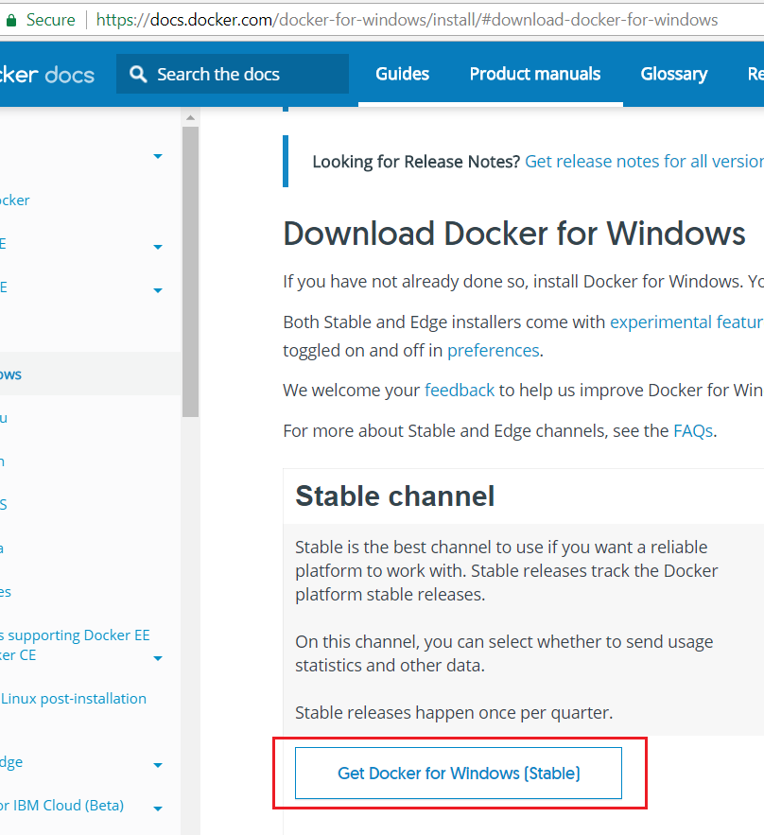  
   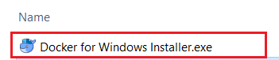
2. Install Docker it will take a while to finish so take some rest and wait for it.
3. Once you finish installed you gonna see this short cut on your desktop.  
   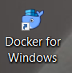
4. Double click on short cut icon to start it (if Hyper-V and Containers are disabled it will pop-up this for you) once you click ok it will take a while and will restart automatically.  
   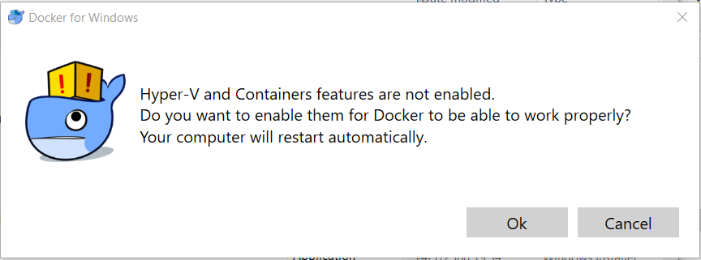
5. After restarted you may see this pop-up just click start button.  
   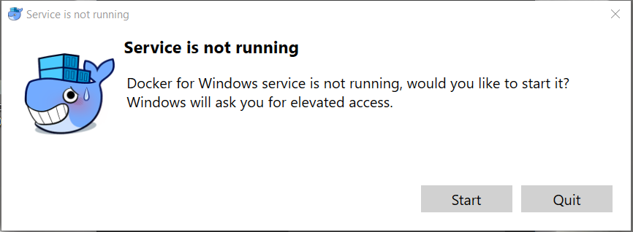
6. You can check Hyper-V and Containers features in windows features after restarted as picture below:   
   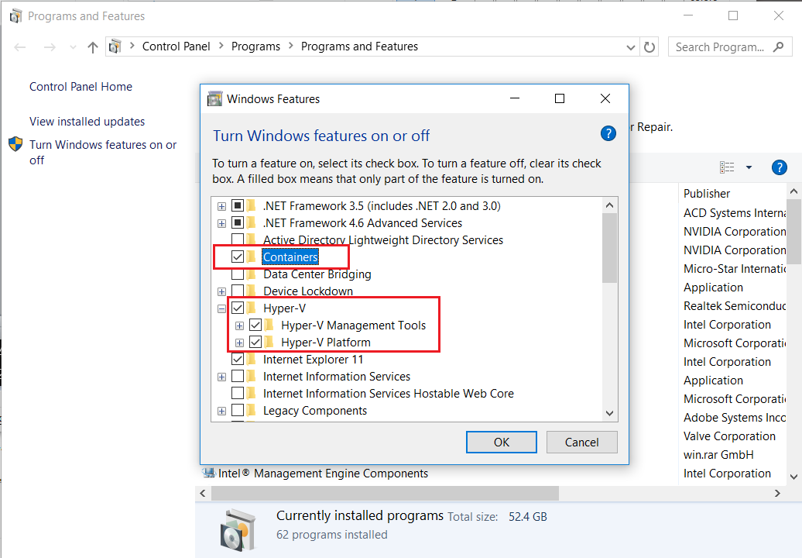  
   **for more info**:   
   <https://docs.docker.com/docker-for-windows/troubleshoot/#virtualization-must-be-enabled>  
   <https://docs.microsoft.com/en-us/virtualization/hyper-v-on-windows/quick-start/enable-hyper-v>
7. Now you can try Docker command using powershell.  
   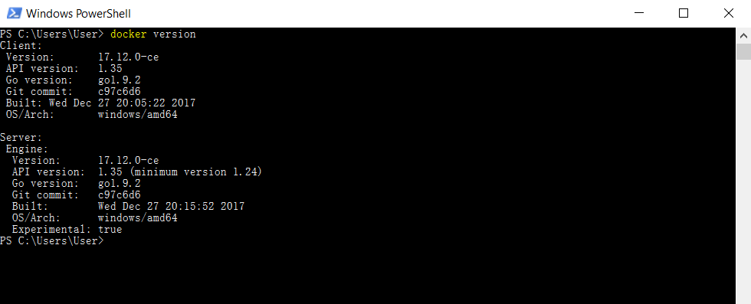
8. Check <https://hub.docker.com/> to download container and try in on your pc.  
   I will use nginx in this section  
   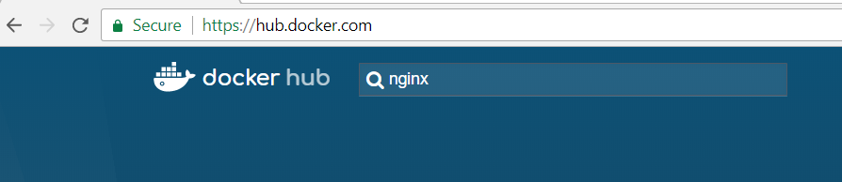  
   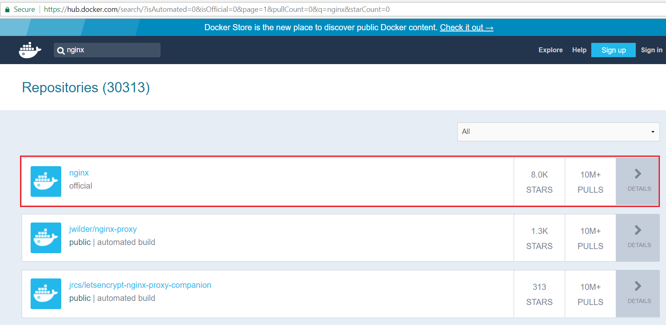  
   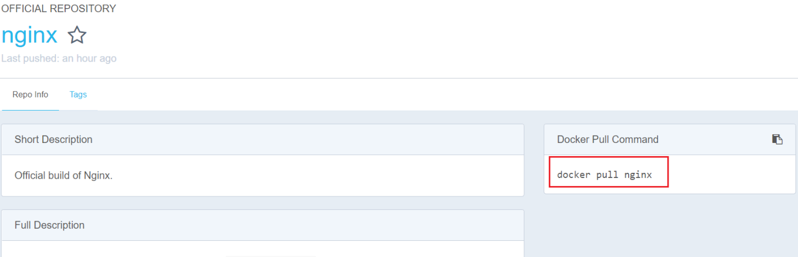  
   docker pull nginx  
   copy docker command above and try it in powershell, you may encounter error like picture below:  
   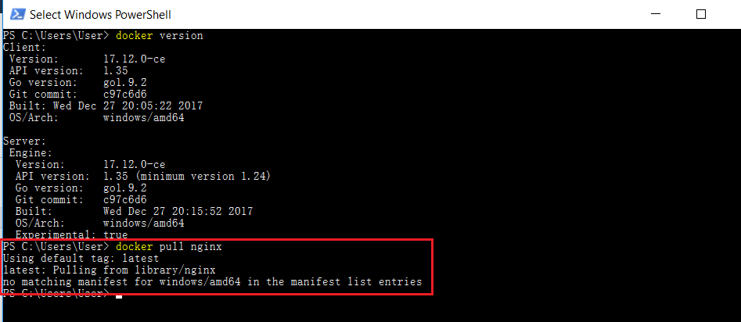
9. Solution to solve this error is Switch to Linux containers as picture below:  
   right click on docker icon and select Switch to Linux containers   
   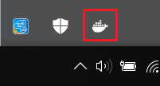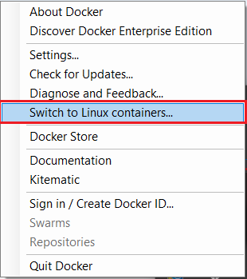
10. After switch container try docker version command again see result as below:  
    linux container on left  
    window container on right  
    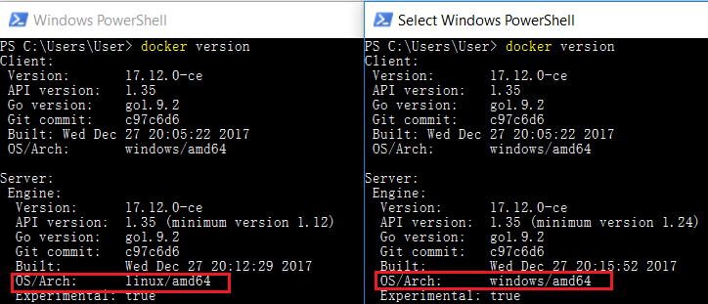
11. Now try command **docker images** to check if there is any docker images on your pc.  
    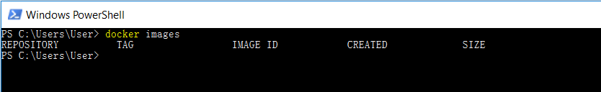
12. Now try command **docker pull nginx** again and see the result.  
    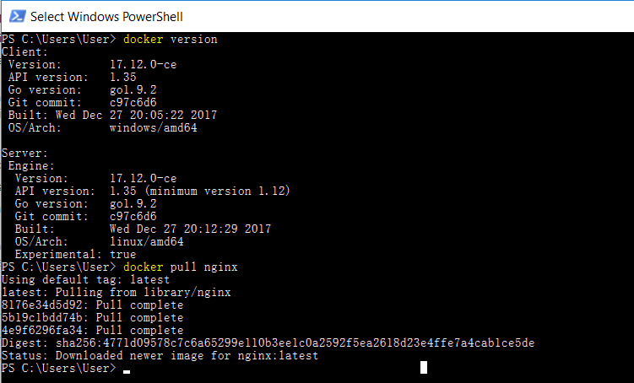  
      
    and use command **docker images** to check images repository   
    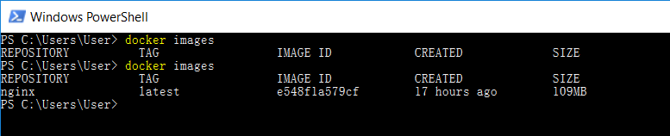
13. In <https://hub.docker.com/_/nginx/> you can read for more info about how to run and config.  
    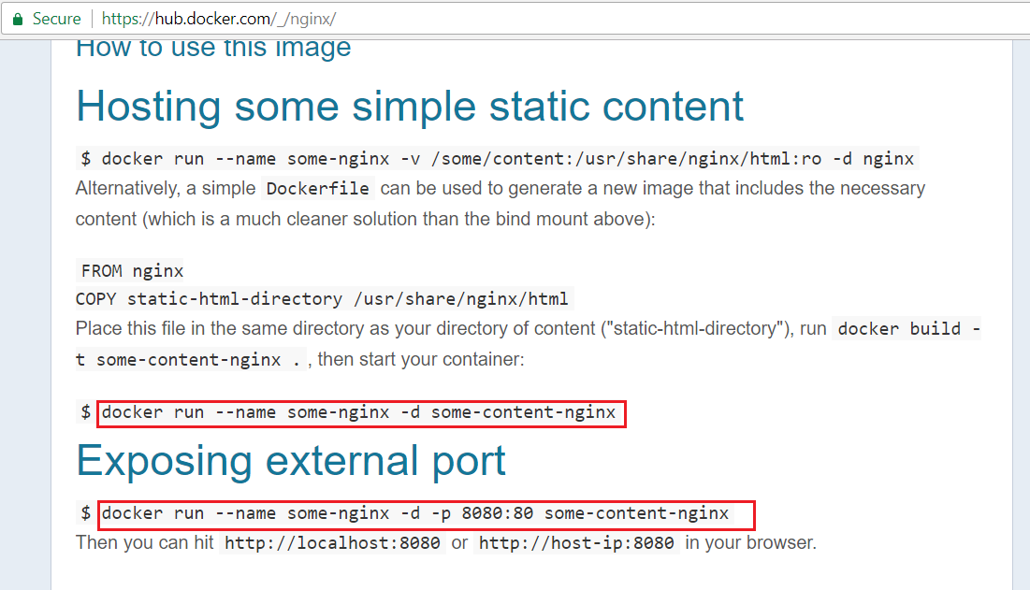  
    try to run it using **docker run --name testNginx -d -p 8080:80 nginx**  
    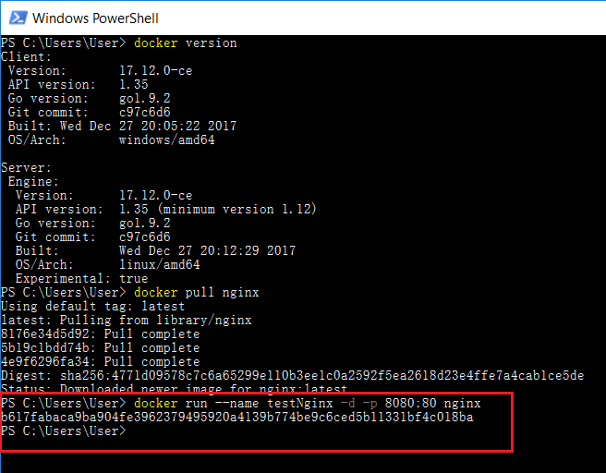  
      
      
    you can use any name to the container in this case I’m using *testNginx* but the end of command should be image name which is **nginx** , if you don’t know your image name try this command>> **docker images**.  
      
    If you want to check docker process try this command >> **docker ps**   
      
    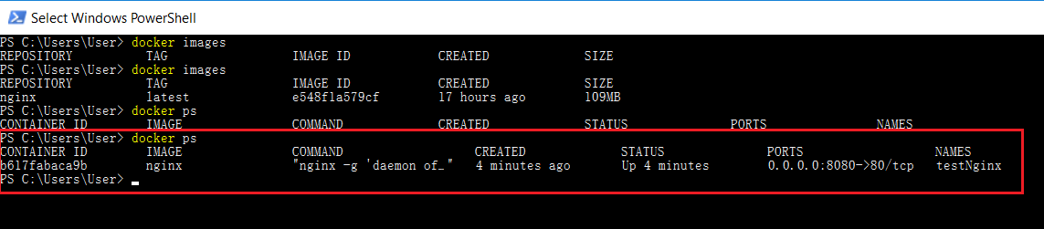now you can access<http://localhost:8080/>you should see result as picture below:  
    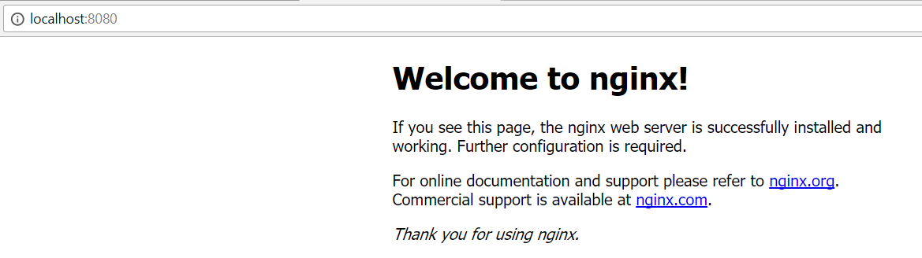  
      
    if you try to run with wrong docker image name you may see this error.  
    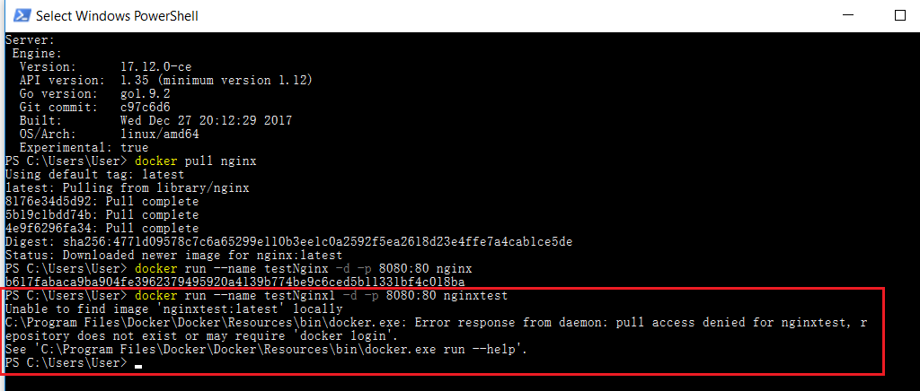  
      
      
      
      
    Stop docker process you need to check process and find container id, then use this command >> **docker stop <Container Id>** and check result as picture below:  
    